Gridstone Questions: Comments
and Resource Guide

Questions Summary

Business Questions

Does Gridstone actually work as advertised?

What is the potential value to customers of the deep data collected by Gridstone?

What is the extent and quality of the semantic data embedded in Gridstone? How was it generated? How will it need to be maintained?

How much does it cost to collect data in Gridstone? What is the split between IS/BS/CF and deep data?

Is the deep data collected by Gridstone a sustainable competitive advantage? How many data points does Gridstone capture? How much does the competition capture? How difficult would it be to replicate the deep data?

Data Questions

Can fundamental and deep data be captured separately?

How long does it take to collect the same data as MEDS in Gridstone? How long does it take to initialize a company, if only Morningstar current is required?
Gridstone Questions: Comments
and Resource Guide

Business Questions

Does Gridstone actually work as advertised? (i.e., a system of knowledge of deep, relevant data points about companies and industries)
Yes, Gridstone works as advertised when collecting data from the main financial statements and notes. The analyses of the Gridstone Master Parameter (MP) list and Display Application (DAP) output reveals that Gridstone, with respect to financials, has a data set that is closely comparable with the current Morningstar output. Furthermore, analyses of the breakout data and operating metrics shows Gridstone’s true capabilities. The deep data points captured by the Gridstone platform appear specifically within their breakout and operating metric data.

Financials
In an analysis of the data points captured in the main financial statements for Prudential Financial Inc. (PRU) and Southwest Airlines, Co. (LUV), Sam compared the data points displayed in Morningstar Equity XOI with the data points captured in Gridstone. The following table highlights the percentage of Gridstone data points that aligned directly with a MEDS counterpart. It is important to note that there are instances where a direct alignment did not exist though the data point could be calculated by combining a few of the existing Gridstone data points (E.g. Net Loans or Trading Assets).

Financial Statement | MEDS Data Points | GSR Data Points | GSR Data Points (%)
Balance Sheet | 105 | 99 | 94%
Income Statement | 67 | 53 | 79%
Cash Flow Statement | 94 | 79 | 84%
Earnings Report | 24 | 24 | 100%
Total | 290 | 255 | 88%

Gridstone’s output of the three main financial statements is clearly defined by both sector and industry classifications. The table below outlines the number of industries within each Gridstone sector classification. In total, there are 141 different industries within 10 separate sector classifications.
 | Number of Industries
Sector Classification (Gridstone) | Gridstone | Morningstar
Communications Services | 3 | 2
Consumer Durables | 15 | 13
Consumer Services and Nondurables | 36 | 28
Energy | 8 | 6
Financial Services | 21 | 29
Health Care | 8 | 10
Industrials | 18 | 23
Materials | 11 | 13
Technology | 17 | 19
Utilities | 4 | 5
Total | 141 | 148
Breakout Data
Gridstone uses breakout data for segment data or data contained within footnotes. In MEDS we refer to breakout data as non-financial data and this data is collected manually in NNFS. Gridstone’s collection coverage overlaps with data points and values collected in the current NNFS. However, unlike NNFS, Gridstone collects general product data even if the product is not one of the company’s business segments. The following table shows the number of values collected per category in NNFS as well as the number of values that Gridstone also covers.

Category | NNFS Values | Gridstone Coverage | Gridstone Coverage (%)
Auditor | 13 | 0 | 0%
Inventory | 7 | 0 | 0%
TSO | 17 | 5 | 29%
Float | 7 | 0 | 0%
Segment | 24 | 21 | 88%
Capital Adequacy | 6 | 0 | 0%
Other | 5 | 3 | 60%
Grand Total | 79 | 29 | 37%

It is important to note that Gridstone covers 88% of the segment data points that are collected manually in NNFS, which would suggest that these data points carry value and are of confirmable value to the marketplace.

Operating Metrics (OMs)
Gridstone uses OMs that gouge the efficiency or profitability of a company relative to industry benchmarks. An OM is a metric that indicates and gauges the efficiency or effectiveness of an operation or process. OMs are also referred to as Key Performance Indicators (KPIs) because both are considered measures of performance.

OMs collected in the Gridstone platform include items such as:
- Room Occupancy Rate
- Number of Hotel Rooms
- Number of Properties
- Revenue per Available Room

The metrics above represent data points that would be collected for Marriot International, Inc. (MAR) which appears in the “Tourism and Resorts” industry and the “Consumer Services and Nondurables” sector. The “Comps View” section of Gridstone’s DAP online interface displays specific standardized metrics that are shared by companies that are in the same industry.

In an analysis conducted by Sam and Dharmit looking strictly at standardized MPs, 27% of the captured deep data is unique to an individual company while a majority of data, 73%, is shared among companies or industries. The following table outlines the results of their analysis of 1,881 companies in Gridstone. The Shared column shows the total number of shared operating metrics that are comparable across companies and industries while the Unique column displays the number of “one-off”, unique and non-comparable data points per Gridstone sector.

Sector | Total | Unique | Shared | Shared (%)
Communications Services | 1,813 | 589 | 1,224 | 68%
Consumer Durables | 1,090 | 493 | 597 | 55%
Consumer Services and Nondurables | 5,252 | 2,303 | 2,949 | 56%
Energy | 7,155 | 1,202 | 5,953 | 83%
Financial Services | 10,535 | 1,703 | 8,832 | 84%
Health Care | 499 | 263 | 236 | 47%
Industrials | 2,133 | 834 | 1,299 | 61%
Materials | 1,304 | 504 | 800 | 61%
Technology | 2,367 | 921 | 1,446 | 61%
Utilities | 1,415 | 335 | 1,080 | 76%
Grand Total | 33,563 | 9,147 | 24,416 | 73%

The following table was also constructed using Sam and Dharmit’s analysis from above. This table represents the number of operating metrics one could expect to be captured on average per Gridstone sector based on the same sample set of companies used.

Sector | Total | Unique | Shared | Shared (%)
Communications Services | 20 | 7 | 13 | 65%
Consumer Durables | 15 | 7 | 8 | 53%
Consumer Services and Nondurables | 14 | 6 | 8 | 57%
Energy | 29 | 5 | 24 | 83%
Financial Services | 46 | 7 | 39 | 85%
Health Care | 3 | 2 | 1 | 33%
Industrials | 8 | 3 | 5 | 63%
Materials | 16 | 6 | 10 | 63%
Technology | 9 | 3 | 6 | 67%
Utilities | 13 | 3 | 10 | 77%
Grand Total | 174 | 50 | 124 | 71%

Source(s): Southwest Airlines, Co. (LUV) Comparison
Prudential Financial Inc. (PRU) Comparison
Gridstone Sectors and Industries
Morningstar Sectors and Industries
Gridstone and NNFS Comparison
Gridstone: Operating Metrics Statistical Summary

What is the potential value to customers of the deep data collected by Gridstone?
This is a qualitative question that cannot be completely answered at this time.

As indicated above, Gridstone collects a significant amount of deep data with respect to both the breakout data and operating metrics. Around 27% (MP view) based on our current research samples of this data is unique to given companies and not comparable across industries/companies. However, approximately 73% of captured operating metrics is comparable across peer companies or industry classifications.

Competitor research is currently on-going. Preliminary findings indicate that S&P, like Gridstone, offers similar supplemental data as well as operating metric data for representative industries. For Bloomberg, it depends whether the operating metrics data is located in a footnote or not. Much of the information provided in Bloomberg varies on a company-to-company or industry-to-industry basis. Finally, it doesn’t appear that operating metrics are included in the fundamental data package for Thomson Reuters.

Additionally, Chris spoke with several Equity Research teams concerning key performance indicators (KPIs) and it was made clear that KPIs allow the analysts to gouge the profitability of a company through various industry-specific metrics. In this case, the wealth of information collected by Gridstone would be an advantage.

What is the extent and quality of the semantic data embedded in Gridstone? How was it generated? How will it need to be maintained?
Outside of the general info found in the M&A (company overview) pamphlet, there is minimal formal documentation from the Gridstone side on collection/production practices or methodologies. Sharon and Sam produced some general-level documentation on Gridstone production practices this fall after participating in multiple demos prior to/during Sharon’s time in Shenzhen. Information can be supplemented where necessary through focused meetings and discussions with Dharmit and other members of the Mumbai team.

The following flow chart created by Sam provides a high-level view of the processes required to commence the collection and maintenance of Gridstone’s deep-data offering. Once the processes are complete, the normal OM collection process is fully merged with the collection of fundamentals and notes data.

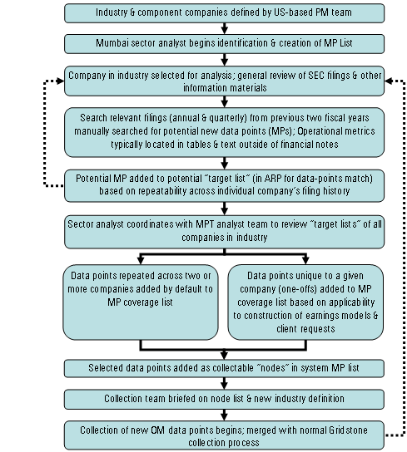
Repeat as necessary
“Maintenance” efforts occur during periodic coverage expansions

Sources: OM Flow Chart
Gridstone: Organizational Overview

How much does it cost to collect data in Gridstone? What is the split between IS/BS/CF and deep data?
The following table shows the total number of MPs corresponding to each of Gridstone’s three final product templates: Insurance, Industrial and Commercial, and Banking and Financial Services. Furthermore, the number of MPs are broken down by Gridstone Parameter Group.
Parameter Group | Insurance | Industrial and Commercial | Banking and Financial Services | Total
Income Statement | 389 | 1,266 | 469 | 2,124
Balance Sheet | 368 | 868 | 514 | 1,750
Cash Flow Statement | 565 | 522 | 400 | 1,487
Operational Metrics | 208 | 4,704 | 580 | 5,492
Supplemental Data | 13 | 588 | 83 | 684
Financial and Operating Ratios | 0 | 50 | 7 | 57
Corporate | 0 | 50 | 0 | 50
Total | 1,543 | 8,078 | 2,053 | 11,674
In total across all product templates, there are 11,674 MPs.
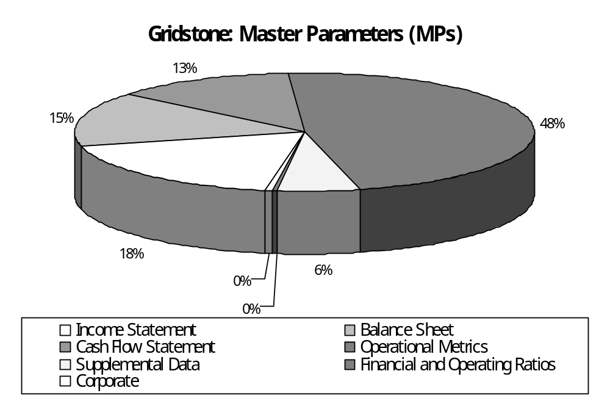
This following study conducted by Rahul identifies the average data processing time when capturing the current Gridstone coverage data set both when initializing a company and when processing any subsequent documents. The table also includes the percentage breakdown of time allocated to each one of the main financial statements as well as the percent of time allocated to capturing notes and operating metrics. The results of Rahul’s time studies’ are as follows:

 | Initialization |  |  | Subsequent Documents
 | Processing Time | Data Points | Time (%) | Processing Time | Data Points | Time (%)
Income Statement | 0:03 | 49 | 2% | 0:03 | 41 | 5%
Balance Sheet | 0:05 | 65 | 3% | 0:02 | 38 | 3%
Cash Flow | 0:03 | 104 | 2% | 0:07 | 84 | 12%
Total Financial Statements | 0:11 | 218 | 7% | 0:12 | 163 | 20%
Notes | 0:14 | 56 | 9% | 0:16 | 71 | 27%
Operating Metrics | 0:15 | 33 | 9% | 0:15 | 33 | 25%
Template and ARP Creation | 1:49 |  | 68% | 0:00 |  | 0%
Search Time | 0:11 |  | 7% | 0:17 |  | 28%
Total | 2:40 | 307 | 100% | 1:00 | 267 | 100%

As mentioned above, once the process of commencing collection of OMs is complete for a company, the process is merged with the collection of fundamentals and notes. The table above represents the inclusion of Operating Metrics in the Gridstone collection process.

Source(s): Insurance Template Master Parameters
Industrial and Commercial Template Master Parameters
Banking and Financial Services Template Master Parameters
Gridstone Time Study: Initialization and Subsequent Documents

Is the deep data collected by Gridstone a sustainable competitive advantage? How many data points does Gridstone capture? How much does the competition capture? How difficult would it be to replicate the deep data?
The OM master parameter lists referred to on page 6 contains information as well as the figures for the number of data points captured by Gridstone. Additionally, the excel workbooks can be sorted and refined to answer any potential follow-up questions regarding the data captured in Gridstone. Sam worked with Dharmit to create processing/organizational documents for the deep data collection processes. Initial findings showed that 27% of the operating metric data points are unique in the MP view while 73% are shared and can be compared across companies and industries.

As mentioned in the tables above, the following represents the total number of MPs collected across Gridstone’s product templates:

- Insurance 1,543
- Industrial and Commercial 8,078
- Banking and Financial Services + 2,053
- Total 11,674

Source(s): Insurance Template Master Parameters
Industrial and Commercial Template Master Parameters
Banking and Financial Services Template Master Parameters

Data Questions

Can fundamental and deep data be captured separately?
Yes, the fundamental and deep data can be captured separately in Gridstone. However, at this time we are uncertain of the technical investment associated with capturing this data separately.

The following table outlines the average processing time and average number of operating metric data points when captured separately from the fundamental data collection process.

 | Operating Metrics
Document Type | Processing Time | Data Points
Annual Document (10-K, 20-F) | 0:18 | 32
Quarterly Document (10-Q) | 0:13 | 33
Total (Average) | 0:15 | 33

The table on page 7 above shows the processing time when initializing a company as well as processing subsequent documents when the collection of fundamental data and deep data is merged together.

Source(s): Gridstone Time Study: Operating Metrics

How long does it take to collect the same data as MEDS in Gridstone? How long does it take to initialize a company, if only Morningstar current is required?
This first study conducted by Rahul identifies the average data processing time when only capturing the current Morningstar coverage data set while initializing a company and when processing any subsequent documents. The initialization statistics represent the time it would take to initiate a new company in the Gridstone Research application, create a new template, and capture only the data points in the current Morningstar coverage. Additionally, the processing statistics for the MEDS January release are included in the column titled “MEDS.” However, the MEDS statistics are not as granular and do not breakdown the processing time per financial statement and instead only represent the processing time for the “Normal” template.

 | Initialization |  |  |  | Subsequent Documents
 | Processing Time | Data Points | Time (%) | MEDS | Processing Time | Data Points | Time (%)
Income Statement | 0:05 | 44 | 7% |  | 0:04 | 43 | 20%
Balance Sheet | 0:05 | 52 | 7% |  | 0:04 | 37 | 20%
Cash Flow | 0:06 | 32 | 8% |  | 0:06 | 57 | 30%
Total Financial Statements | 0:16 | 128 | 22% |  | 0:14 | 137 | 70%
Notes | 0:01 | 9 | 1% |  | 0:01 | 7 | 5%
Template and ARP Creation | 0:50 |  | 67% |  | 0:01 |  | 5%
Search Time | 0:08 |  | 10% |  | 0:04 |  | 20%
Total | 1:15 | 137 | 100% | 0:23 | 0:20 | 144 | 100%

The next study provides more of an apples-to-apples comparison between MEDS and capturing data in the Morningstar template in the Gridstone Research application. In this study, no ARPs are created and the entire Morningstar template is replicated in one shot. Thus, new line items that appear in subsequent filings are either mapped or ignored.

 | Initialization |  |  |  | Subsequent Documents
 | Processing Time | Data Points | Time (%) | MEDS | Processing Time | Data Points | Time (%)
Income Statement | 0:06 | 50 | 3% |  | 0:02 | 31 | 12%
Balance Sheet | 0:07 | 54 | 3% |  | 0:03 | 37 | 19%
Cash Flow | 0:12 | 97 | 6% |  | 0:04 | 56 | 25%
Total Financial Statements | 0:25 | 201 | 12% |  | 0:09 | 124 | 56%
Notes | 0:06 | 28 | 3% |  | 0:03 | 10 | 19%
Template and ARP Creation | 2:46 |  | 78% |  | 0:00 |  | 0%
Search Time | 0:16 |  | 7% |  | 0:04 |  | 25%
Total | 3:33 | 229 | 100% | 0:23 | 0:16 | 134 | 100%

Currently, normal template creation time is between 1 – 4 hours depending on the sector and document type. If Gridstone is able to automate the template creation process, new template creation time would be reduced to between 5 – 10 minutes max. Furthermore, the template can be replicated for all companies using automation resulting in a drastically reduced processing time.

Source(s): Gridstone Time Study: Morningstar Data Set Analysis 1
Gridstone Time Study: Morningstar Data Set Analysis 2

Glossary

Aa

As Reported Parameter (ARP)
As Reported Parameters contain every line item from AOR but names are standardized (ARP) for that particular company based on review of industry standards and historical company filings. Every ARP must be mapped to a Master Parameter (MP) in a Master Parameter Template (MPT). ARPs for a company are stored in the Company Parameter Template (CPT)

If an analyst wants to add a new ARP in the CPT and cannot find the appropriate MP to map it to, they must have senior research create a new MP and approve the ARP mapping.

Bb

Break Outs (BO)
Break out items include any supplemental financial data to the main financial tables: income statement, balance sheet, and statement of cash flows. Break out information also includes segment related data.

Cc

Capture Application (CAP)
This application is used to collect data according to the As Reported Parameter (ARP). Additionally, this application is used to identify new ARPs and where new ARPs do not have a mapping to the Master Parameter (MP). Lastly, the application is used to request new MPs as well as store attribute data point data.

Company Parameter Template (CPT)
These are company specific templates that identify the As Reported Parameters (ARP) per company. Additionally, CPTs identify and define any company-specific break out items such as by product.

Comps View
In the Display Application (DAP), there is functionality to view metrics shared across companies between industries referred to as Comps View. This tab allows Gridstone users to see a comparison of standardized valuation, financial performance, and operating metrics by quarter and fiscal year end.

Dd

Display Application (DAP)
This application is used to set up As Reported Parameters (ARPs) and Company Parameter Templates (CPTs). This application is also used in defining the Master Parameter Template (MPT) hierarchy as well as defining Standard Line Items (SLIs). ARP-to-MP mappings as well as company attribute data is stored in this application.

Mm

Master Parameter (MP)
The master taxonomy which was developed based on XBRL several years back. Every MP has an additional “company specific” MP which is used to map company/industry specific data from the ARP to the MPT.

Master Parameter Template (MPT)
Includes templates for: Industrial and Commercial, Bank and Financial Services, and Insurance MPs

Oo

Operating Metric (OM)
A metric that indicates and gauges the efficiency or effectiveness of an operation or process.

Ss

Standard Line Item (SLI)
Standard line items (SLIs) appear in the Master Parameter Templates (MPTs) for each of the three templates. These items represent the standardized line item naming schema for data items in the three main financial statements. Additionally, SLIs for Operating Metrics is currently work-in-progress at Gridstone.

Tt

Template Application (TAP)
This application is used to set up As Reported Parameters (ARPs) and Company Parameter Templates (CPTs). It is also used to define the Master Parameter (MP) taxonomy as well as the Standard Line Items (SLIs). ARP-to-MP mappings and company attribute data is stored in this application.

